Cylinder Head Temperature (CHT) Gauge Display – CGEA1.3

Functional Description

The purpose of the Cylinder Head Temperature gauge display is to provide a digital and graphical read out of the vehicle’s cylinder heads temperature to the customer.

The cylinder head temperature is measured by the Cylinder Head Temperature Sensor. The Cylinder Head Temperature Gauge display correlates the EngIpcDsplyCht_Te_Actl signal from the PCM and the Operational Mode to display the temperature in degrees Fahrenheit or degrees Celcius, depending on the selected units.

The Instrument cluster is responsible for any scaling or unit changes that are required. The Cylinder Head temperature shall follow the globally selected units and display its value in either English or Metric units. The display range should be 140 degrees F to 320 degrees F (60 degrees C to 160 degrees C) with linear scaling. The coolant temperature flat response gauge provides the over temperature warning indication, so this gauge done not need a red zone.

There is a digital numeric and graphical virtual gauge that displays the temperature of the cylinder heads. The Cylinder Head Temperature gauge shall provide a digital readout and an analog gauge with a rotating pointer to indicate the temperature of the vehicle’s cylinder heads. The Cylinder Head Temperature Gauge pointer shall rotate from bottom to top or left to right to register increasing CHT and rotate in the opposite direction for decreasing CHT.

Interfaces

Interface Context Diagram (I/O Block Diagram)
Cylinder Head Temperature Gauge Display Context Diagram

Inputs

IR-REQ-297429/A-Internal
- Operational_Mode
- Cylinder_Head_Temp_display _Cfg
- Display_Units_MC – Refer to the Display Unit Selection Control Function – CGEA STSS for more information.
- SVT_Cfg (Internal Config Bit): Set at the supplier EOL to differentiate a SVT end item part.

MUX message on the HS_CAN Bus

SIG-REQ-297417/A-EngIpcDsplyCht_Te_Actl Signal

Signal Name | Size  (bits) | Detail | Units | Res. | Offset | State Encoded | Min. | Max.
EngIpcDsplyCht_Te_Actl | 8 |  | Deg. C | 1 | -60 |  | -60  (0x0) | 195  (0xFF)

IR-REQ-297433/A-Outputs
- Cylinder Head Temperature Display
- Cylinder Head Temperature Virtual Gauge Display

Function/Performance

F-REQ-297434/A-Operational Modes

Mode | Differentiating Vehicle Conditions
Sleep Mode | Cylinder Head Temperature display / virtual gauge Inactive
Limited Mode | Cylinder Head Temperature display / virtual gauge Inactive
Normal Mode | Cylinder Head Temperature display / virtual gauge Active/Inactive
Crank Mode | Cylinder Head Temperature display / virtual gauge Active/Inactive

Voltage Levels

Refer to the Cluster Features table located in the Operational Modes and Voltage Range Strategies Section of this SPSS.

Human-Machine Interface

Visual

Indicator Graphics / Display Format

TFT Display Graphics Reference
For TFT display graphics, refer to approved studio PNG data. Below are few examples:

Indicator Color Coordinates

As per program specific appearance requirements.

HMI-REQ-297418/A-Indicator Characteristics

Description of Gauge | BASE Scale Range | SVT Scale Range | Scale Span | Operating Span
North American | 140ºF to 320⁰F  60⁰C to 160⁰C | 150⁰F – 400⁰F  50⁰C - 200⁰C | Program specific HMI | Program specific direction

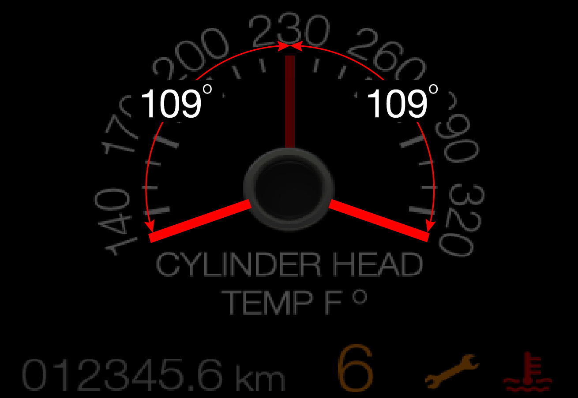
Reference – Operating Scan shown (218 angular degrees).
Scale span 200 angular degrees (140 F to 320 F)

Audio

None

Switch Control Logic

Not Applicable

PFM-REQ-297440/A-System Accuracy

- Shall indicate the data contained in EngIpcDsplyCht_Te_Actl Signal.

Operation: Performance and Functional

Subsystem Algorithm Flowchart / State Diagram

F-REQ-297419/A-Cylinder Head Temperature Gauge Configuration

F-REQ-297420/A-Cylinder Head Temperature Display Process

F-REQ-297421/A-Cylinder Head Temperature Virtual Gauge display Process

HMI-REQ-297614/A-Numerical CHT and Virtual Gauge Display

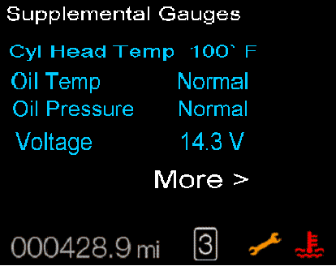
Gauge with min - mid - max pointer positions shown

Operation Description (supports algorithm flowchart /state diagram)

F-REQ-297422/A-EngIpcDsplyCht_Te_Actl Signal Missing
- Gauge pointer shall move to the lowest defined chaplet at max rate when EngIpcDsplyCht_Te_Actl signal is declared missing.

F-REQ-297423/A-Gauge Needle Waver Limitations
- The Cylinder Head Temperature Gauge display shall not exhibit needle waver exceeding 1/3 of an angular degree with a steady commanded input.

F-REQ-297424/A-Gauge Pointer Overshoot Behaviour
- Pointer overshoot and return to temperature indicated by EngIpcDsplyCht_Te_Actl Signal shall not exceed one angular degree.

F-REQ-297425/A-Gauge Display Signal Sampling Rate
- The Cylinder Head Temperature Gauge display shall sample the EngIpcDsplyCht_Te_Actl Signal at the predefined message's periodic rate.

F-REQ-297426/A-Gauge Pointer Position Refreshing Rate
- The cluster shall update the pointer position at least every 100 msec.

F-REQ-297427/A-Gauge Pointer Target Position Calculation
- The cluster shall linear interpolate between input values to calculate the target position to ensure smooth pointer movement.

F-REQ-297602/A-Cylinder Head Temperature Value Filtering
- The Cylinder Head Temperature shall execute the same filtering as on the engine coolant temperature gauge.

Cylinder Head Temperature Value Filtering Reference
- Refer to the “Engine Coolant Temperature Gauge” STSS for more information.

F-REQ-297428/A-Cylinder Head Temperature Display Configuration Disabled
- The Cylinder Head Temperature display and the virtual gauge shall not be displayed if Cylinder_Head_Temp_display_Cfg is Disabled (0x0).

FS-REQ-297442/A;1-Function Safety Classification (EMC)

B

NVM-REQ-297430/A-Memory Storage

Parameter Name | Description | Value at  Battery Connect | Value at  Module Wake-up
Cylinder Head Temperature Display | Displays the numerical value of the cylinder head temperature in selected units. | Inactive | Inactive
Cylinder Head Temperature Virtual Gauge display | Use to display virtual cylinder head temperature gauge display | Inactive | Inactive
EngIpcDsplyCht_Te_Actl Signal | CAN signal sent from the PCM for cylinder head temperature gauge | -60 Deg. C (0x0) | -60 Deg. C (0x0)
Cylinder_Head_Temp_display _Cfg | State indicator for feature presence controlled via CAN at EOL at VO plant. Set to Disabled at Cluster Supplier Manufacturing Plant | Use Stored Value | Use Stored Value
Operational_Mode | 4 state indicator for cluster operational mode | Limited | Limited, Normal or Crank

Prove Out

No

Error Handling

Missing Message Strategy

Missing Signal Reference

The signals will be declared missing as per the Diagnostics section of this SPSS.

DTC States Reference

DTCs states and history will be determined as per the Diagnostics section of this SPSS.

Diagnostics

Self Test

None.

Engineering Test Mode

Reference section “Dealer / Engineering Test Mode (ETM)”

Part II Performance

DTC-REQ-297431/A-Supported Diagnostic Trouble Codes (DTCs)

DTC | Description
C10000 | Lost Communication with PCM

DCR-REQ-297432/A-DID DE0x

Block  Num | Block Description | Size (bits) | Byte | Bit | State: Description | "0" | "1" | Default | Comments
PACKETED BLOCKS
$XX | Option Content (B&A) | 1 | * | * | Cylinder Head Temp Display | Disabled | Enabled | Disabled
*Byte and bit location to be identified in Part II Specification for this cluster

Reference Specification

- Func. Criticality EC-0048
- Mod. PWR-up / Reset EC-0049
- Low-High Vol. Perform. EC-0058
- Jump Start EC-0062
- Instr. & Gauges (indic. Grad) IS-0015
- Oper. Voltage Perf. IS-0052
- Oper. Voltage Func. IS-0053
- Sys. Audible Noise IS-0103
- Pointer Waver IS-0108
- Instr. Scale Dir. IS-0127
- Symbol Usage 01-0238 / 01-0239
- Symbol Leg. 01-0240
- Placement - Parts Loc. 03-0001
- Glare/Reflections 16-0068
- Reflection 17-0018
- Harmony: Graphics / Font / Ill. 17-0040
- Ergo - Access. 17-0052
- Ergo - Operablility 17-0053
- Control & Display Loc. 17-0060
- Logical grouping Function and Usage 17-0062
- Assoc. of Controls with Disp. & elem. 17-0063
- Ill. Controls & Disp. 17-0074
- Id. Legibility 17-0081
- ID. Coding / Labeling 17-0083
- Logic of Op. 17-0120
- Op. Stereotypes 17-0121
- Interpretation 17-0122
- Feedback 17-0124

Revision History
SPSS Module Revision History

Revision Level | Name | Change Description | Date
1.0 | V.Patel | Initial release for CGEA 1.3, based Cylinder Head TemperatureGauge S197 v1.3 STSS dated March 30, 2012. | 7/31/2012
1.1 | Mlenkner | Changed Virtual_Gauge_Cfg to Cylinder_Head_Temp_display_Cfg throughout | 12/11/12
1.2 | V. Patel | Figure 1 update to DE0x  1.2.2 remove reference to internal SVT control bit  Add figure 2  1.5.3 update to DE0x and to use Cylinder Head Temp Display bit  Added operating range for S550 SVT variant. | 11/8/2013
1.3 | A. Mishra | Initial VSEM Requirement Document | 2/19/2018

